**INTRODUCTION TO**

**MATLAB**

**LAB # 01**



**Spring 2020**

**CSE301L Signals & Systems Lab**

Submitted by: **Shah Raza**

Registration No. : **18PWCSE1658**

Class Section: **B**

“On my honor, as student of University of Engineering and Technology, I have neither given nor received unauthorized assistance on this academic work.”

Student Signature: ______________

Submitted to:

**Engr. Durr-e-Nayab**

Wednesday, March 4, 2020

**Department of Computer Systems Engineering**

**University of Engineering and Technology, Peshawar**

## Lab Objective(s):

• Introduction to Matlab

• Matlab Environment

• Matlab Help

• Variable arithmetic

• Built in Mathematical Functions

• Input and display

• Timing functions

• Introduction to M‐files

## Task # 01:

Converting numeric data stored as double‐precision floating point by default, to an 8‐ bit integer, 16‐ bit integer, 32‐ bit integer and 64‐ bit integer.

### Problem Analysis:

For conversions we will use the following functions:

* int8
* int16
* int32
* int64

### Code:

### Part(A):

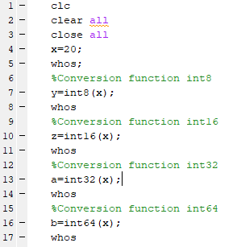

### Part(B):

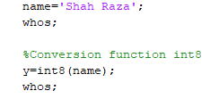

### Output / Graphs / Plots / Results:

### Part(A):

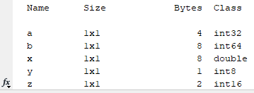

### Part(B):

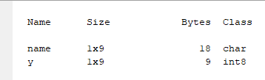

## Task # 02:

Prove any Five Trigonometric expressions.

### Problem Analysis:

To prove these trigonometric expressions, we calculate RHS and LHS separately and assign them to different variables and check their values. If these values match, that means RHS=LHS and hence the expression is proved.

### Code:

a=pi;

b=2*pi;

t1=clock;

%First Expression

c1=sin(a+b);

d1= sin(a)*cos(b) + cos(a)*sin(b);

%Displaying LHS and RHS

disp('LHS is: ');

disp(c1);

disp('RHS is: ');

disp(d1);

%Total Time Taken

T1=etime(clock, t1);

t2=clock;

%Second Expression

c2= sin(a) + sin(b);

d2= 2* sin((a+b)/2) * cos ((a-b)/2);

%Displaying LHS and RHS

disp('LHS is: ');

disp(c2);

disp('RHS is: ');

disp(d2);

%Total Time Taken

T2=etime(clock, t2);

t3=clock;

%Third Expression

c3= cos(a) * cos(b);

d3= 1/2 *(cos(a-b) + cos (a+b));

%Displaying LHS and RHS

disp('LHS is: ');

disp(c3);

disp('RHS is: ');

disp(d3);

%Total Time Taken

T3=etime(clock, t3);

t4=clock;

%Fourth Expression

c4=cos(a+b);

d4= cos(a)*cos(b) - sin(a)*sin(b);

%Displaying LHS and RHS

disp('LHS is: ');

disp(c4);

disp('RHS is: ');

disp(d4);

%Total Time Taken

T4=etime(clock, t4);

t5=clock;

%Fifth Expression

c5= sin(a) * cos(b);

d5= 1/2 *(sin(a+b) + sin (a-b));

%Displaying LHS and RHS

disp('LHS is: ');

disp(c5);

disp('RHS is: ');

disp(d5);

%Total Time Taken

T5=etime(clock, t5);

### Output / Graphs / Plots / Results:

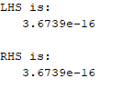**First expression:**

Time taken = 0.0470s

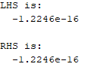**Second expression:**

Time taken = 0.0310s

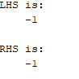**Third expression:**

Time taken = 0.0460s

**Fourth expression:**

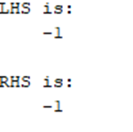Time taken = 0.0460s

**Fifth expression:**

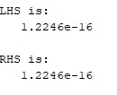Time taken = 0.0310s

## Task # 03:

Write a Program to Calculate CGPA.

### Problem Analysis:

In order to create a CGPA calculator we need grade points and credit hours for each subject. Then calculate the product of grade points and credit hours for each subject, add them and divide the sum by total number of credit hours.

### Code:

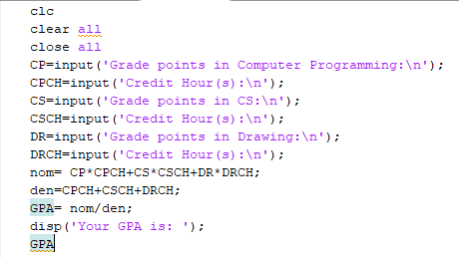

### Output / Graphs / Plots / Results:

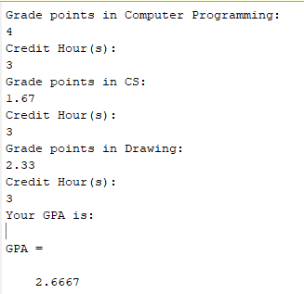

## Task # 04:

### Write a simple code to swap the values of two variables of double type using M-file. Create the logic in such a way that no third variable is used. Show the etime for this code.

### Problem Analysis:

This task can be performed by adding the two variables and storing them in first variable, then subtract the second variable from the first and store it in the second variable. The second variable now has the values of the first variable. In order to swap the first variable now subtract the second variable from the first and store it in the first.

### Code:

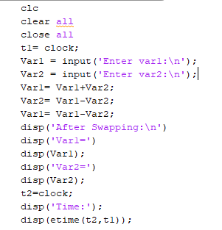

### Output / Graphs / Plots / Results:

